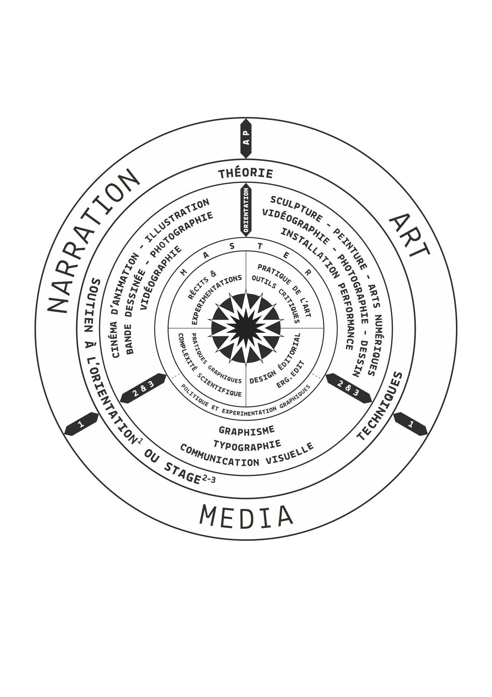

APPLICATION FORM FOR INCOMING STUDENTS
ACADEMIC YEAR 2022-2023

This application should be completed in BLACK CAPITALS and must be returned by e-mail duly signed and stamped to :

Sammy Del Gallo
international projects
Rue du Page 87
1050 Bruxelles
Tél : 32 2 538 98 29
E-mail : sammy.del.gallo@erg.be
Please send with this form

2 photo-copies of your passport/ID card
a copy of a valid insurance form while you’re studying at erg
a digital portfolio
an artistic statement
a proof of French proficiency

Deadline for admissions : 1st of May

STUDENT ‘S PERSONAL DATA
Family Name :
First Name(s) :
Place and Date of birth :
Nationality :
Permanent adress :
ZIP-Code :
Country :
Phone or mobile phone :
E-mail :
Current year of study at home institution :
Achieved ECTS credits till now :

INTENTED PERIOD OF STUDY AT ERG
Full Academic Year or First semester (delete as appropriate)

ORIENTATION AT ERG
1 .To be chosen between
Videography, Typography, Sculpture, Photography, Painting, Installation/Performance, Illustration,Drawing, Graphic Design, Visual & Graphic Communication, Animation Cinema, Comics, Digital Arts
+ Internal internship (1 choice)
----------------------------------
2.To be chosen from all the orientations (different from the first choice), or between serigraphy, etching (on metal or on wood) and Model drawing classes

LANGUAGE COMPETENCE
Mother tongue :
Other languages :
Knowledge of French language :

SENDING INSTITUTION DATA
Full name :
City & country :
Erasmus code & PIC code :
Field of study :
Name of institutional or departemental coordinator :
E-mail :
Signature and Official stamp :

HOW CAN YOU DEVELOP YOUR ARTISTIC RESEACH WITHIN THE PEDAGOGICAL PROJECT* AT ERG (please provide a personal statement) ?
*Projet pédagogique de l'erg

PERSONAL STATEMENT (please continue on a separate sheet if necessary)

STUDENT’S SIGNATURE AND AGREEMENT

